Contours Blacktown – Polar Training Watch Order Form
Name
Mobile Number
Email Address
Model Number
Colour (if applicable)
Contours Price
Deposit Paid (date & amount)
Balance Owing
Balance Paid (date & amount)
Watch Collected (member - sign & date)
Watch Collected (staff – sign & date)

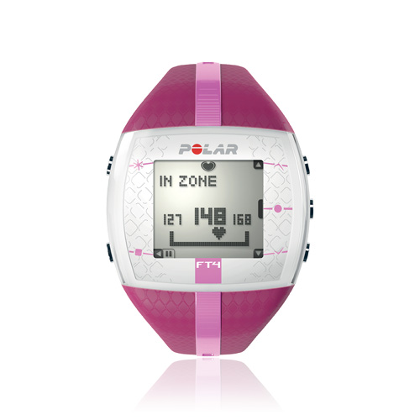 | 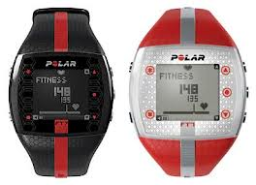 | 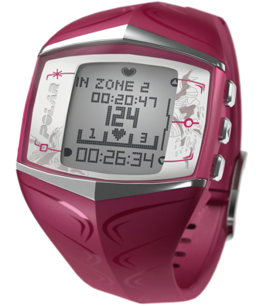
FT 4  $115 | FT 7 (Ladies – Red)  $135 | FT 60  $185
Available Colours
Pink  Gold  Silver  Blue | Red  Black/Red  Black/Gold  Black/Silver | Pink  Black

